Tree localization and autonomous motion planning vis UAVs

Amir Niaraki

With the aim of conducting an accurate tree by tree measurement, three fundamental steps should be taken:

1. Extracting each tree’s GPS location from raw satellite **image**
2. Designing a simulation environment to map the trees, in order to train the drone using motion planning algorithms.
3. Transferring the learned 3D path from the simulation to the intelligent robot

Computer/machine vision is now a vital module in autonomous robot navigation. In our case, we have used several color channels to extract meaningful features from images over almond orchards. Now we can have the location of the trees in any farm, and the size of the crown as a preprocessed data before drone deployment. The framework has been tested with several images scrapped from free google earth satellite imagery as depicted below:

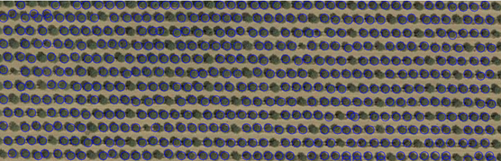

Step 2 is an in progress work, where the SOTA physical engine, unreal engine will be utilized to mimic drone flight dynamic and the objectives’ visual properties.

The ultimate goal is to pipeline the process in the backend, by starting from chosen target farm, creating tree locations as waypoints, replicating the farm in simulation environment, develop the navigation plan through power-optimized path planning algorithm, and finally transfer the navigation plan to the drones’ onboard computer.